The beginning of miracle
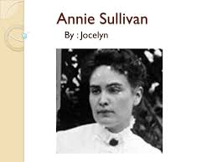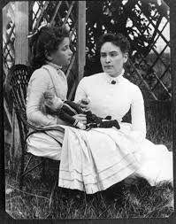 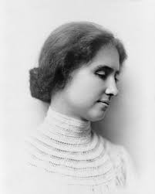 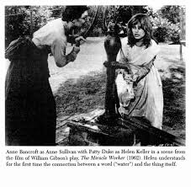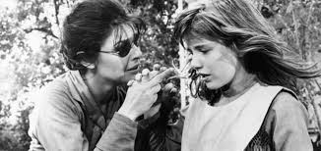Saturday, March 3, 2012, marks the 125th anniversary of Helen Keller meeting Anne Sullivan, the "miracle worker", who would change her life and set her on the path toward becoming one of the most remarkable women of all time. Struck by what's believed to have been scarlet fever as an infant, Helen Keller was both blind and deaf by the age of 19 months. Having uttered a few simple words and heard sounds as an infant, being blind and deaf made her feel isolated, causing her to often throw fits and tantrums. After schools for the blind refused to admit her, the Kellers sought the help of inventor Alexander Graham Bell, who had spent the prior decade working with the deaf and experimenting with hearing devices. He then suggested they contact the Perkins Institute for the Blind, who sent one of their students, Anne Sullivan, to work with Helen Keller. Sullivan arrived at the Keller's home in Alabama on March 3, 1887. She brought Helen a doll as a gift, but immediately began to fingerspell "d-o-l-l" into Helen's hand, hoping that she would associate the two. Over the next few months, Anne and Helen worked together nonstop, even moving into a cottage together on the Keller's property, so they could maintain focus on communication. Their lessons together often became physical and violent during Helen's frequent moments of frustration. Helen's breakthrough occurred one day at the water pump, when Sullivan poured water on one of Helen's hands while fingerspelling "w-a-t-e-r" in the other. For the first time, Helen made the association between an object and what was spelled in her hand. According to her autobiography, Helen then spent the rest of the day demanding that Sullivan spell out the words for countless other objects.
The Water Scene from the 1962 film, The Miracle Worker. Keller spent the rest of her life sharing her message with the world by attending Radcliffe College, writing books, and touring the world. But her extraordinary accomplishments can be traced back to that moment at the water pump, when Anne Sullivan communicated with her for the first time. She recounts this day in detail in The Story of My Life, which served as the basis for William Gibson's play, The Miracle Worker. First produced as a teleplay in 1957, The Miracle Worker opened on Broadway on October 19, 1959, with Anne Bancroft playing Anne Sullivan and Patty Duke starring as Helen Keller. Unlike Helen's parents, Sullivan attempts to teach at the same time as disciplining, believing that "obedience without understanding is blindness, too." The Miracle Worker depicts the obstacles both Keller and Sullivan had to overcome in order for them to be able to communicate with each other. Today, technology enables people to connect in countless ways over many devices, but 125 years ago, Anne Sullivan's patience and determination allowed her to do what seemed impossible—to teach a 7-year-old Helen Keller to communicate with the world.
The Water Scene from the 1962 film, The Miracle Worker. Keller spent the rest of her life sharing her message with the world by attending Radcliffe College, writing books, and touring the world. But her extraordinary accomplishments can be traced back to that moment at the water pump, when Anne Sullivan communicated with her for the first time. She recounts this day in detail in The Story of My Life, which served as the basis for William Gibson's play, The Miracle Worker. First produced as a teleplay in 1957, The Miracle Worker opened on Broadway on October 19, 1959, with Anne Bancroft playing Anne Sullivan and Patty Duke starring as Helen Keller. The physical nature of the play stunned theatergoers, as actresses slapping and wrestling each other was rare at the time. However, knowing that the story was based on a real Helen Keller made the final "water" scene all the more powerful, and the play became an instant commercial and critical success. In addition to winning the Tony Award for Best Play, Bancroft and Duke both earned Tonys for their performances. After a long casting process, both Bancroft and Duke were ultimately asked to reprise their roles for the 1962 film. Shot in black and white, Penn used mostly hand-held camera shots for the many physical scenes between Bancroft and Duke. Both actresses wore heavy padding under their costumes to prevent injury. The film depicts the teaching method that both Keller and Sullivan describe in their letters. Almost immediately, the film shows Anne hovering over Helen and observing her behavior. Instead of trying to provoke her, she waits to see Helen's natural instincts. Unlike Helen's parents, Sullivan attempts to teach at the same time as disciplining, believing that "obedience without understanding is blindness, too." The Miracle Worker depicts the obstacles both Keller and Sullivan had to overcome in order for them to be able to communicate with each other. Today, technology enables people to connect in countless ways over many devices, but 125 years ago, Anne Sullivan's patience and determination allowed her to do what seemed impossible—to teach a 7-year-old Helen Keller to communicate with the world.

